**Year 12 General Biology**

**Task 7: Inheritance & Change Test**

**SECTION ONE:** Multiple choice answers

Cross (X) through the correct answer.

|  |  |  |  |  |
| --- | --- | --- | --- | --- |
| **1** | a | xxx | c | d |
| **2** | a | b | xxx | d |
| **3** | xxx | b | c | d |
| **4** | a | b | c | xxx |
| **5** | a | b | c | xxx |
| **6** | a | b | xxx | d |
| **7** | a | xxx | c | d |
| **8** | xxx | b | c | d |
| **9** | xxx | b | c | d |
| **10** | a | b | c | xxx |

**Short Answer Section: (14 marks)**

11) The diagram below is of genetic information are where it can be found. (4 marks)

1. **Add** the following labels to the diagram indicating each:

Chromosome DNA Genes Nucleus

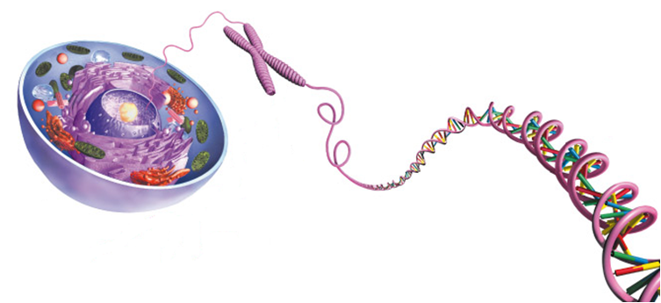

Nucleus labelled (1)

Chromosome labelled (1)

Genes labelled (1)

DNA labelled (1)

1. **Write** the complementary base pair to the following sequence: (1 mark)

**A G G T C C A T C G C A T A C G A C A C T A**

**T C C A G G T A G C G T A T G C T G T G A T**

1. **Discuss** how mutations bring new alleles into the gene pool and what affect this has on a population. (2 marks)

Mentions mutations and variation caused (1)

Effect mutations have on population (1)

1. **List** the two differences between somatic and germline mutation (2 marks)

Two differences mentioned (2) / one difference mentioned (1)

1. **Compare** and **contrast** artificial selection and natural selection in the venn below, **identifying** two similarities and two differences between the two selection processes.

(6 marks)

**Artificial Selection** **Natural Selection**

2 similarities (2)

2 differences for artificial selection (2)

2 differences for natural selection (2)

1. **Draw** and **label** a nucleotide in the box below. (3 marks)

Drawing of nitrogen base (0.5)

Label of nitrogen base (0.5)

Drawing of phosphate (0.5)

Label of phosphate (0.5)

Drawing of sugar (0.5)

Label of sugar (0.5)

1. **Discuss** how Natural Selection causes an impact on the survival and reproduction of peppered moths. (2 marks)

How natural selection impacts survival (1)

How natural selection impacts reproduction (1)

1. **Explain** how the environment influences genetic expression in Hydrangeas. (2 marks)

Discuss what environment does to genes in hydrangeas (1)

Phenotypic effect on hydrangeas (1)

**Extended Response**

1. **Discuss** how genes and chromosomes determine the sex of an offspring, and **explain** the environmental influences on sex determination and their impact with the use of an example. (8 marks)

Effect chromosomes have on sex determination (2)

Identify 2 environmental influences (day length and temperature) (2)

Describe effect of both environmental influences (2)

Explain with use of example (2)

**End of Assessment**